Activity-APPLICATION BUILDING USING WEKA TOOL
2. Flower Species Classification
Build a WEKA application that identifies the species of a flower from its
physical measurements.
• Dataset: Iris dataset
• Attributes: Sepal Length, Sepal Width, Petal Length, Petal Width
• Target: Iris Species
• Algorithm: J48 or Naive Bayes
• Tasks:
1. Load the Iris dataset.
2. Select the classification algorithm.
3. Train the model.
4. Evaluate its accuracy.
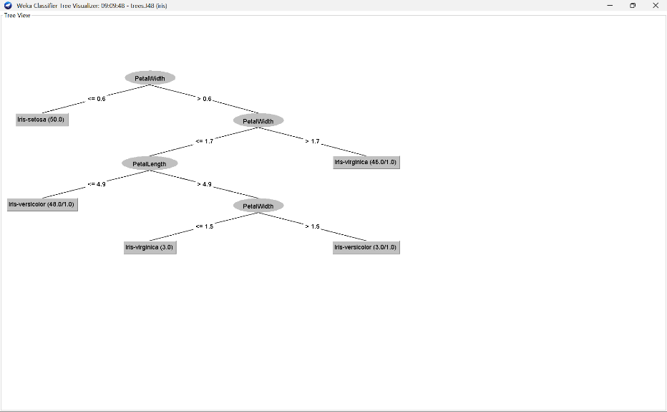r.
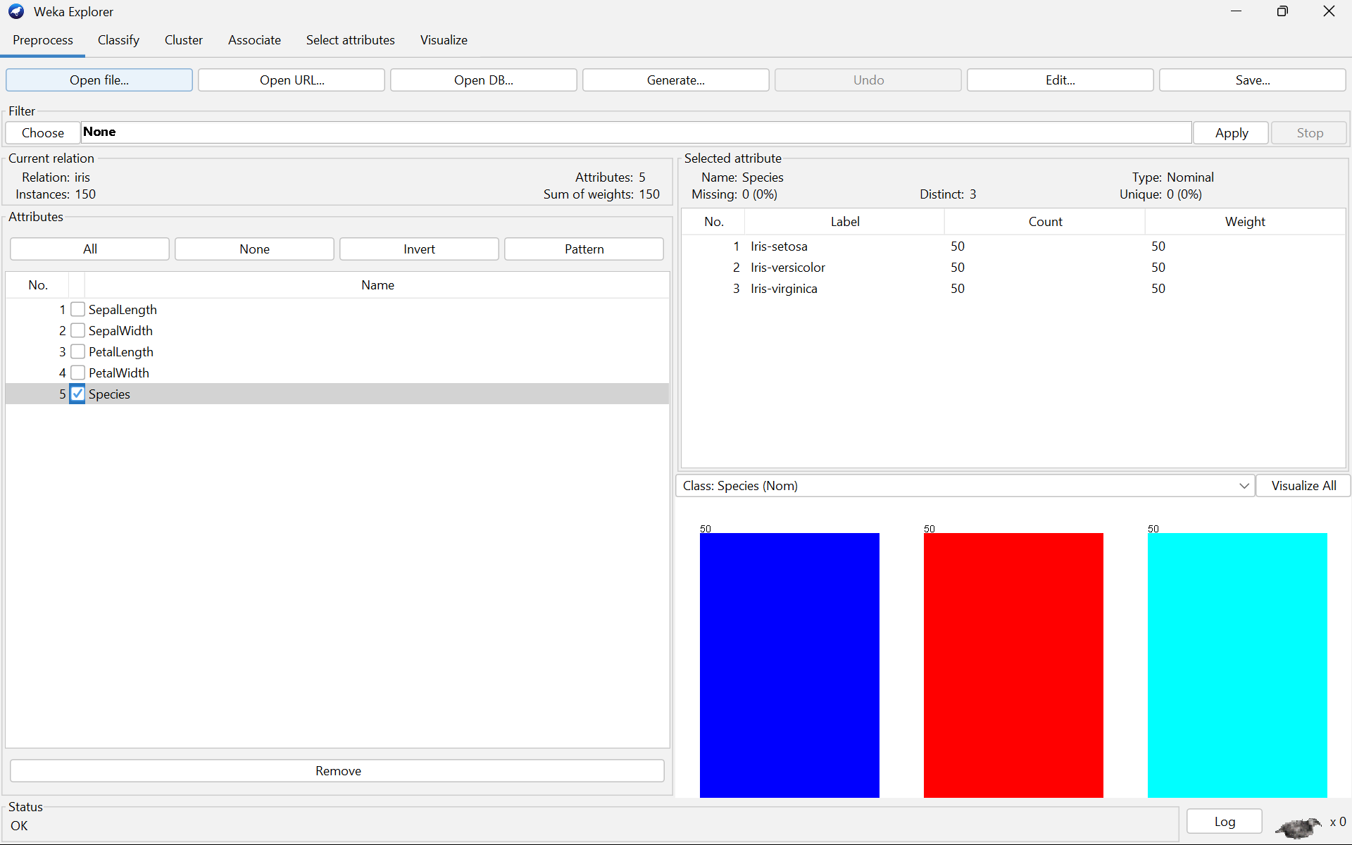
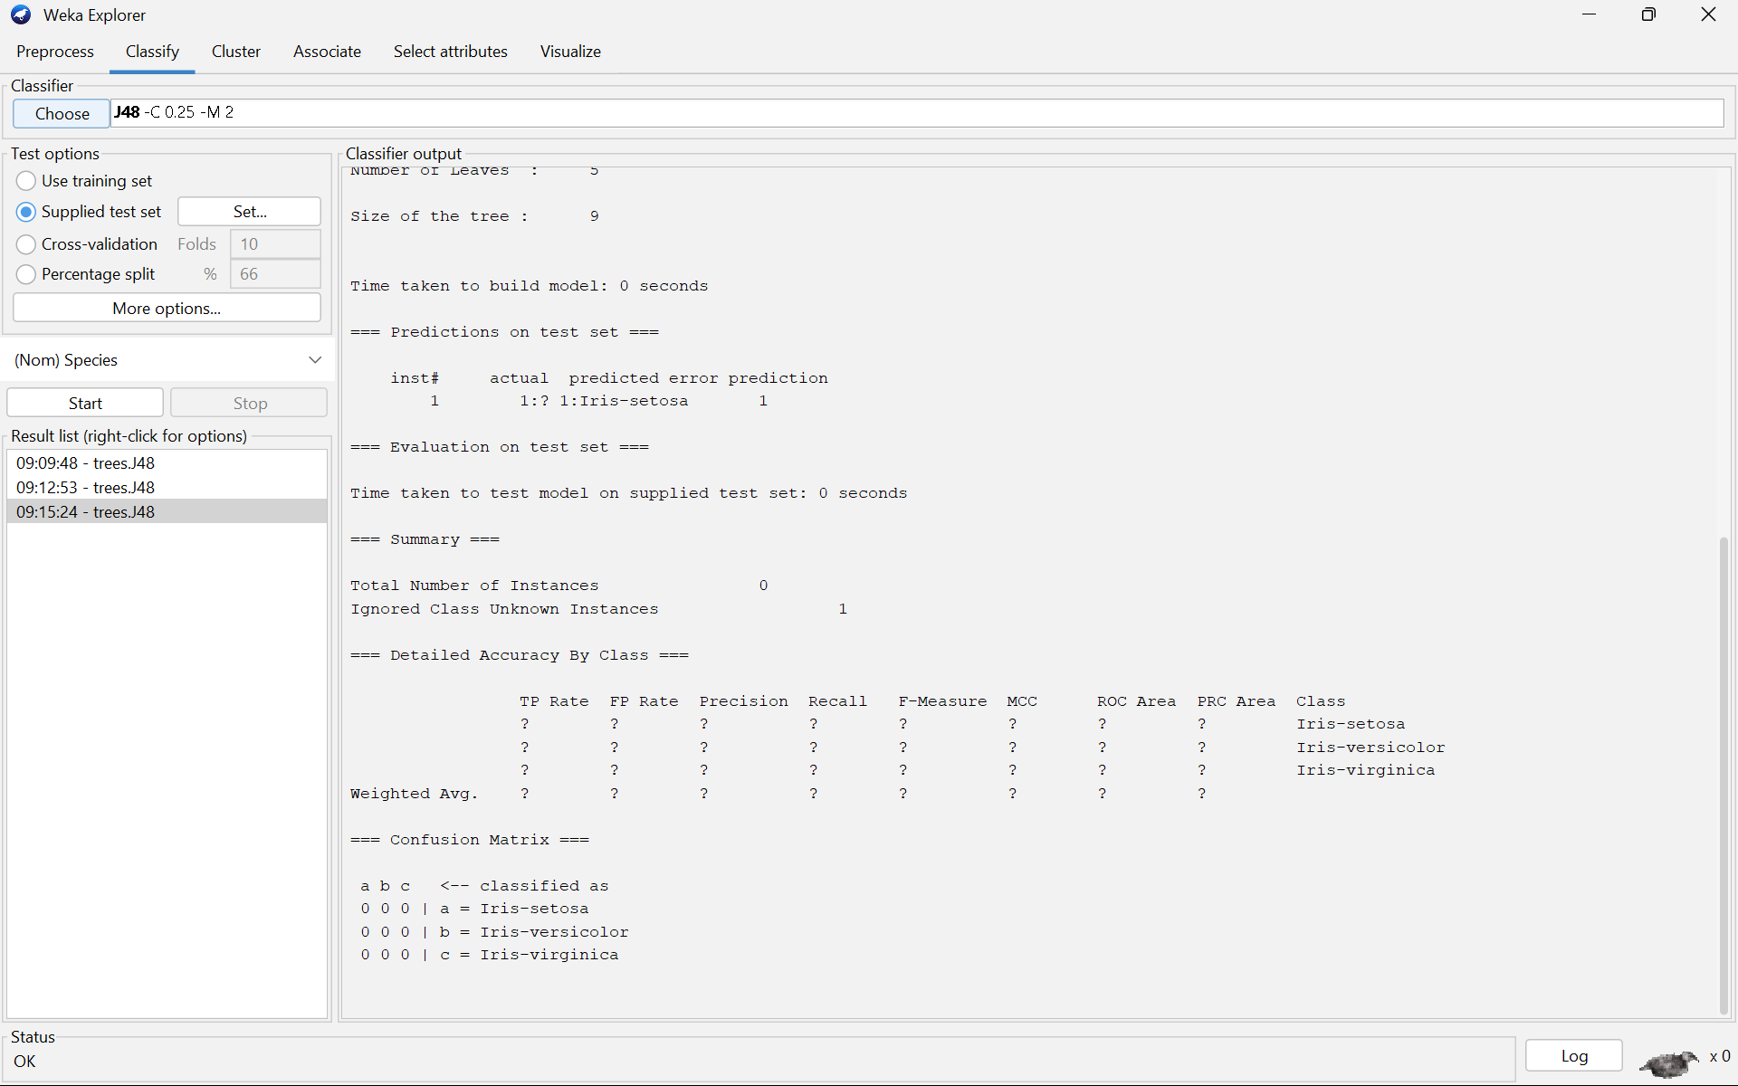

Fruit Quality Prediction
Build a WEKA application that predicts whether a fruit is good or bad based on
its characteristics.
• Attributes: Weight, Color, Size, Firmness
• Target: Quality (Good/Bad)
• Algorithm: J48 Decision Tree
• Tasks:
1. Create/load the fruit dataset.
2. Preprocess the data.
3. Build the decision tree.
4. Find the classification accuracy.
5. Predict the quality of a new fruit.

